TEMPERATURE DETECTION

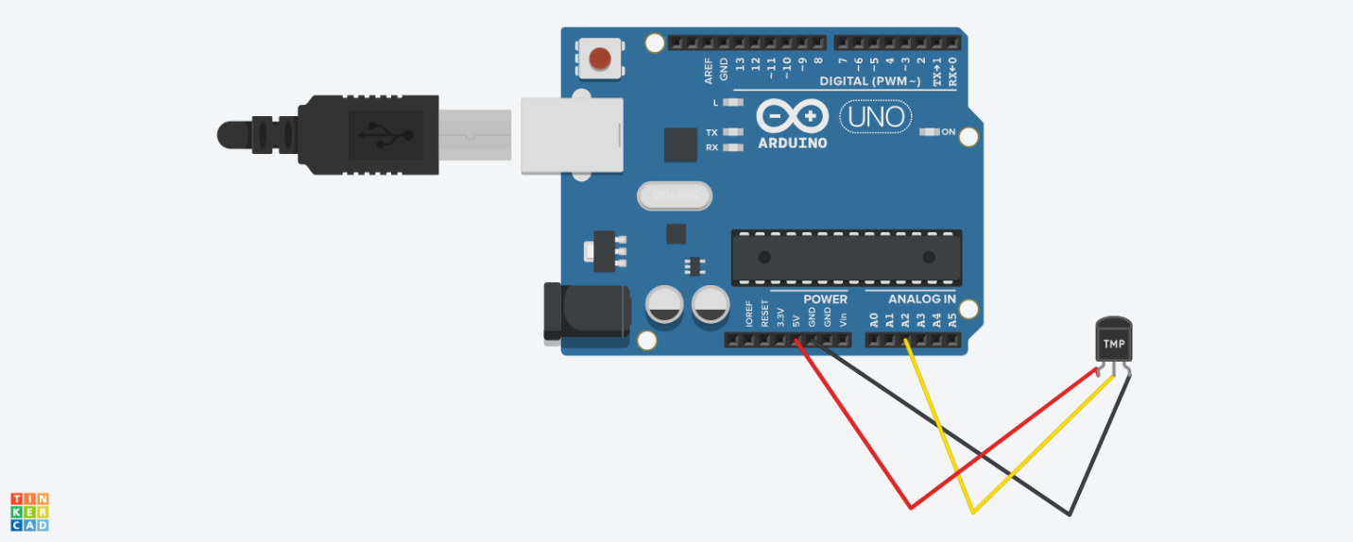

// C++ code

//

void setup()

{

pinMode(LED_BUILTIN, OUTPUT);

}

void loop()

{

double avalue=analogRead(A2);

Serial.print("avalue is:");

Serial.println(avalue);

double ca= avalue/1024;

double v= ca*5;

Serial .print("voltage is:");

Serial .println(v);

double o =v-0.5;

Serial . print("offest voltage :");

Serial . println(o);

}